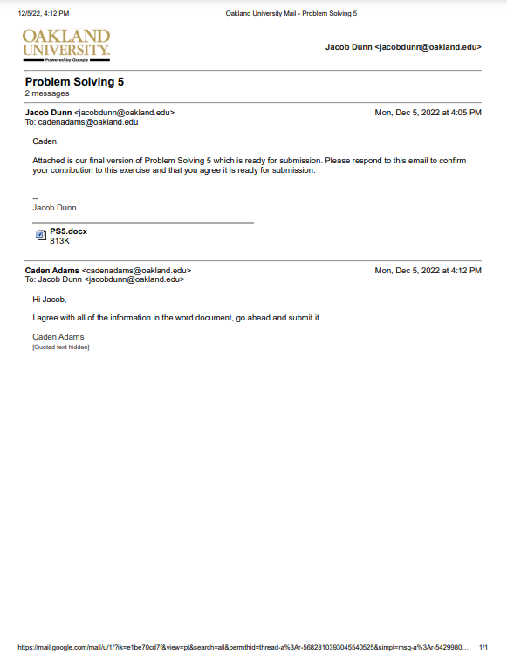

A:

i.

|  |  |  |
| --- | --- | --- |
| Sensor Value | First Derivative | Second Derivative |
| 21 |  |  |
|  | 4 |  |
| 25 |  | 0 |
|  | 4 |  |
| 29 |  | 0 |
|  | 4 |  |
| 33 |  | 1 |
|  | 5 |  |
| 38 |  | 1 |
|  | 6 |  |
| 44 |  | -12 |
|  | -6 |  |
| 38 |  | 10 |
|  | 4 |  |
| 42 |  | 0 |
|  | 4 |  |
| 46 |  | 0 |
|  | 4 |  |
| 50 |  | 0 |
|  | 4 |  |
| 54 |  |  |

It makes more sense to use the first derivative since the values are more consistent for this derivative. If the first derivative is < or > 4 then noise.

ii.

|  |  |  |
| --- | --- | --- |
| Sensor Value | First Derivative | Second Derivative |
| 176 |  |  |
|  | 15 |  |
| 191 |  | 2 |
|  | 17 |  |
| 208 |  | 2 |
|  | 19 |  |
| 227 |  | 2 |
|  | 21 |  |
| 248 |  | 2 |
|  | 23 |  |
| 271 |  | -9 |
|  | 14 |  |
| 285 |  | 6 |
|  | 20 |  |
| 305 |  | 2 |
|  | 22 |  |
| 327 |  | 2 |
|  | 24 |  |
| 351 |  | 2 |
|  | 26 |  |
| 377 |  |  |

It makes more sense to use the second derivative since the values are more consistent for this derivative. If the second derivative is < or > 2 then noise.

B:

|  |  |  |  |  |  |
| --- | --- | --- | --- | --- | --- |
| 35 | 43 | 46 | 24 | 21 | 13 |
| 43 | 53 | 59 | 38 | 34 | 22 |
| 43 | 58 | 61 | 42 | 34 | 24 |
| 22 | 39 | 43 | 44 | 35 | 24 |
| 19 | 35 | 36 | 37 | 28 | 20 |
| 14 | 24 | 27 | 26 | 21 | 13 |

Example calculation for row 2 column 5:

20*1/9 + 28*1/9 + 55*1/9 + 20*1/9 + 64*1/9 + 66*1/9 + 20*1/9 + 22*1/9 + 21*1/9 = 35

After the mean filter was applied, the noise was reduced to values more consistent with the rest of the table. The black and white noise are now gone.

C:

D:

E:

